Why the Queen is never going to abdicate

The House of Windsor won’t follow Queen Beatrix’s example in the Netherlands. Our monarch believes the job is God-given and for life
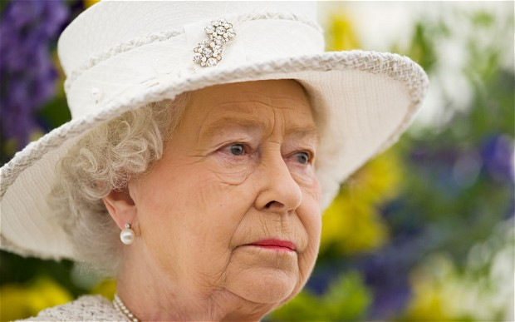
Firm favourite: it is really the popular respect that keeps the Queen on the throne
Photo: Geoff Pugh
By Harry Mount
10:00PM GMT 29 Jan 2013
Prince Charles must sometimes wish he could go Dutch. Aged only 74, Queen Beatrix of the Netherlands has just chosen to hand over the throne to her 45-year-old son, Prince Willem-Alexander. Meanwhile, our 86-year-old Queen shows no signs of passing on the top job to her 64-year-old heir, the oldest ever Prince of Wales.
Is there any chance our Queen will follow Dutch precedent? Not an earthly, is the consensus among royal insiders.
“She won’t abdicate,” says Sarah Bradford, author of Queen Elizabeth II: Her Life in Our Times. “That’s not what she does, or what the British monarchy does. There’s no tradition of abdication here – it goes against the informal rules of our constitutional set-up. But it is what the Netherlands Royal Family does.”
Queen Beatrix is the third Dutch queen in a row to hand over power voluntarily. In 1948, the 68-year-old Queen Wilhelmina, Beatrix’s grandmother, abdicated due to ill health, after 58 years on the throne. Her daughter, Queen Juliana, reigned for 32 years until she was 71, when she handed on the throne to her daughter.
Abdication is fast becoming a tradition in Holland. But it’s a tradition that’s in no danger of catching on over here.
“The links between the British and the Dutch royal families are strong – Queen Beatrix’s grandmother, Queen Wilhelmina, was evacuated to Britain during the Second World War,” says Bradford. “But that doesn’t mean they share the same attitudes. In fact, when you got a Dutch king coming over here, like William III, he stuck to the English ways and didn’t abdicate.”
Britain hasn’t just had a monarchy that’s lasted more than a millennium, it’s also had monarchs who keep ruling right to the end.
That might be a sticky end – whether it’s Charles I losing his head in 1649; or William Rufus, with an arrow through his lung in the New Forest in 1100; or Richard III, killed on Bosworth battlefield in 1485 and thought to be buried beneath a municipal car park in Leicester.
British monarchs are allowed to go mad, like George III. They can turn hermit, like Queen Victoria, dubbed the Widow of Windsor after her self-enforced seclusion in Windsor Castle on Prince Albert’s death. But one thing runs through their blue bloodline – they keep hanging on, until death parts them from the throne.
“I do feel sorry for the Prince of Wales, waiting and waiting, while his mother looks better and better,” says Bradford. “She’s not staying on because of any concern about his abilities as a king. The Queen simply feels she must do her duty, and she’s never even contemplated abdication.”
Ironically, one of the factors that keeps the Queen resolutely in harness is the only voluntary abdication in British history: that of her uncle, Edward VIII, in 1936. The crisis rocked the country, the monarchy, the Church of England and the Queen’s personal life.
It was because of an abdication that the Queen went from being a 10-year-old girl, with a relatively small chance of inheriting the throne, to becoming the most famous woman in the world.
It was because of an abdication and the pressures of office – or so the Queen Mother thought – that her gentle-spirited husband, George VI, died at the premature age of 56. You can see why the Queen doesn’t much like the A word.
The British taste for long-term monarchs is unusual, not just in Holland, but across the Continent, too. Jean, the Grand Duke of Luxembourg, now 92, also abdicated in favour of his son, Henri, in 2000.
In fact, they’ve been pretty keen on getting rid of monarchs altogether across the Channel. France’s last monarch, Napoleon III, was deposed in 1870; Portugal’s went in 1910.
The Second World War did for several kings. The communists forced Peter II of Yugoslavia to stand down in 1945. Italy’s last king, Umberto II, ruled for a month before he was kicked out in a 1946 referendum. The last king of Romania, Michael I, now 91, was forced to abdicate in 1947 by the Communist Party. The Greek monarchy was abolished in 1973.
Spain has jumped from monarchy to republic, and back again. When Juan Carlos became king in 1975, Spain hadn’t been a monarchy since 1931, when the Second Spanish Republic was declared. To make things messier, Juan Carlos’s grandfather, Alfonso XIII, didn’t abdicate his rights to the throne until 1941. So Juan Carlos’s father, the Infante Juan of Spain, Count of Barcelona, never ruled, despite only dying in 1993, aged 79.
Across the world, however, the Queen does have a few long-lived rivals, who don’t go in for abdication either. King Abdullah of Saudi Arabia is 88. King Rama IX of Thailand, 85, who succeeded to the throne in 1946, is the only monarch to rule longer than our Queen.
Generally speaking, though, the British are unusual. The truth is, we don’t like change much.
We don’t like revolutions – the Civil War apart. And we like to hang on to our monarchs for as long as possible, with the exception of Catholic James II; we kicked him out in 1688, to be replaced by the Protestant Dutch king, William of Orange, and Queen Mary.
The lack of English revolutions has astonished those who are used to them abroad. Otto Hintze, the pre-war German historian, said England was made up of living fossils, dependent on a feudal system that had been toppled practically everywhere else in Europe.
The monarch’s landholdings have been extraordinarily robust. The Duchy of Cornwall – owned by Prince Charles and set up by Edward III in 1337 – still has 160 miles of coastline, most Cornish rivers, the Isles of Scilly and more than 54,000 hectares of land.
This continuity of land ownership, and sustained hereditary power, by royal – and aristocratic – families is uniquely British. Other monarchies – and individual monarchs – have been brought down by economic crises, invasions, putsches, wars and civil wars.
But British monarchs have largely survived until the end of their reign because of the tempering effect of parliamentary democracy. Louis XVI paid for an absolute monarchy with his head; our monarchs survived by handing over much of their constitutional power.
The royal powers that remain are considerable, particularly during times of political uncertainty – like after the 2010 election when, for four days, it wasn’t clear that any party leader could form a sustainable government.
Despite the political vacuum, there was no danger of anarchy on the streets. While the Coalition thrashed out its terms, a much-respected ruler was already in place, as she had been for the previous 58 years.
For all her constitutional power, it is really the popular respect that keeps the Queen on the throne, and will keep her there until she dies.
She could, theoretically, abdicate tomorrow if she wanted. But ultimately she won’t because we don’t want her to – as the spontaneous outburst of popular support showed at last year’s Diamond Jubilee.
Her constancy and steadfast adherence to a job she believes is for life instils in us a nation-defining sense of confidence.
The longer our Queen stays on the throne, the more secure we all are.

