True scale of EU migration could be more than double official figures and real number may not emerge until eve of referendum

Britain's official statistics body announces review into migrant figures amid concerns real figure could be at 2.25million over five years - not the 1million quoted by Government
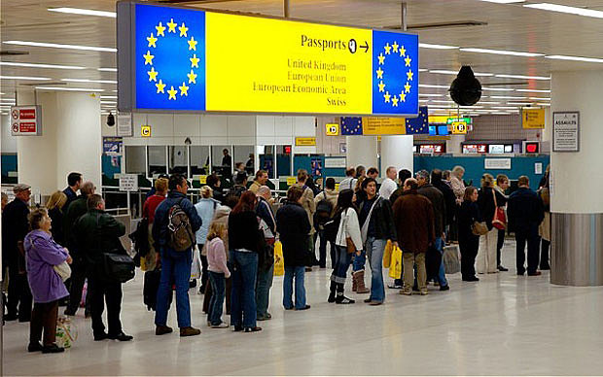
Out campaigners must address what happens to those EU migrants already living here in the event of an Out vote
By Steven Swinford, Deputy Political Editor
8:00PM GMT 11 Mar 2016
The Office for National Statistics has announced an official review of migration figures amid concerns that more than a million migrants have come to Britain than figures suggest.
According to official figures 1million EU migrants came to Britain over the past five years, but over that same period 2.25million registered for national insurance numbers.
Eurosceptic Cabinet ministers have called on David Cameron to publish figures revealing the number of active insurance numbers being used by migrants.
The ONS, which produces Britain's national statistics, has said that it wants to use the figures as part of its review to ensure that the public have a more "complete picture".
The review will be published alongside official net migration figures, which are expected to show that he number of migrants coming to Britain is at near record levels.
Jonathan Portes, Principal Research Fellow at the National Institute of Economic and Social Research, said that the review is likely to be a "big moment" during the referendum campaign.
He has tried to use Freedom of Information laws to try to obtain the figures from the Government but has been repeatedly rejected.
He said: "The fact that the Office for National Statistics is going to look at these different sources and reconcile them is entirely welcome.
"This is an important issue, we know the current numbers are far from perfect and the Government has data which is highly relevant. They are doing their best to hide it from us."
Official figures suggest that 257,000 EU migrants came to Britain last year, but over the same period 630,000 EU citizens registered for a national insurance number.
Official figures suggest that 257,000 EU migrants came to Britain last year, but over the same period 630,000 EU citizens registered for a national insurance number.
David Cameron has refused a request to release the figures, claiming that the difference is accounted for by short term migrants.
Official migration figures are based on a survey of more than 800,000 migrants as they enter and leave Britain, known as the International Passenger Survey.
The ONS said that "at times when migration patterns change significantly, there is a risk that the International Passenger Survey design may need to be changed to fit these".
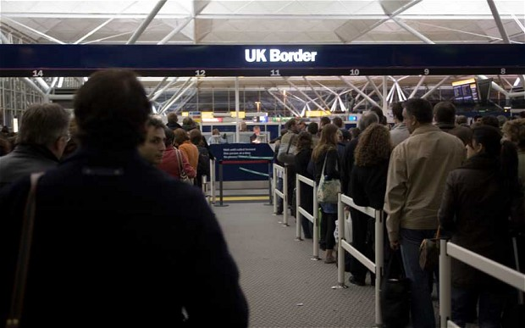Immigration is growing, but where has everyone been coming from? Photo: ALAMY
It said: "When available, DWP and HMRC data on national insurance number activity (those who have applied for a national insurance number and are still active in the UK) will be incorporated to provide additional information for the users of our statistics and a more complete picture."
Earlier this month John Whittingdale, the Culture Secretary, told The Daily Telegraph: "There is already enormous concern on the basis of the numbers that that are published. The suggestion that they may understate the position is a cause for even greater concern.
"I have heard the reasons why national insurance numbers don't necessarily reflect actual levels but at the very least that's a debate which we need to have and I can see no reason why we can't have the figures.
"The massive influx that has occurred as a result particularly of the expansion of the EU is putting pressure on all of the public services - housing, education, health.
"It is creaking at he seams. There is a very strong feeling that his is a small country and we simply cannot go on having an enormous influx over which we have no control."
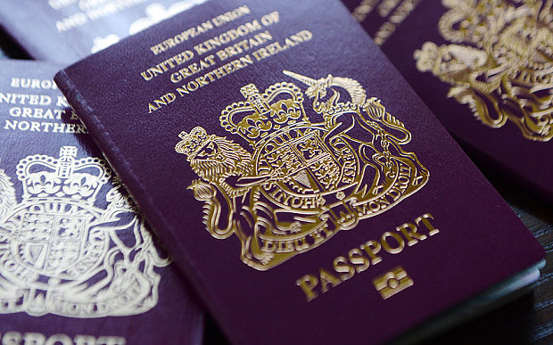Passports are to be checked upon leaving the United Kingdom Photo: Andy Rain/EPA

